Mira Jamous 11926792 HW2 Data structure

Here is a demo of how the code works

1. 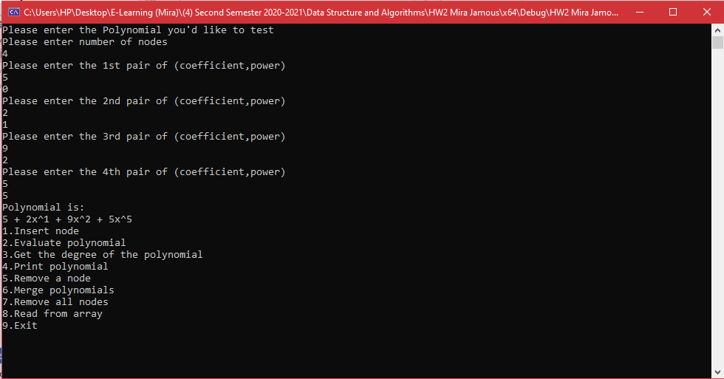The cmd asks the user to enter the poly we’re gonna test
2. 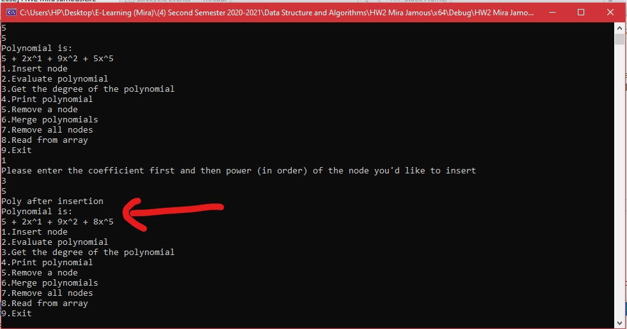Inserting a node with coefficient 3 and power 5

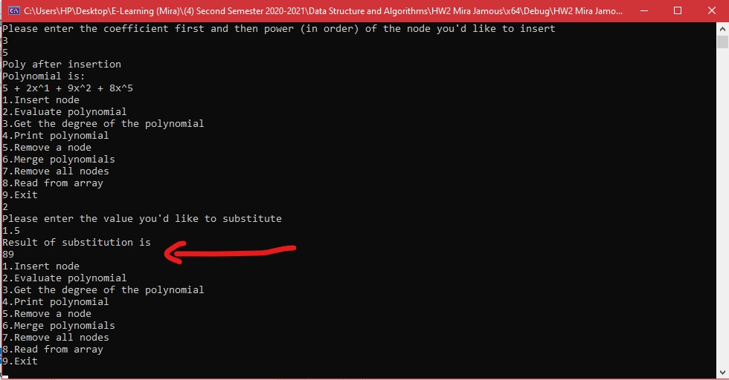3)here is the evaluation with the value of 1.5 in the polynomial

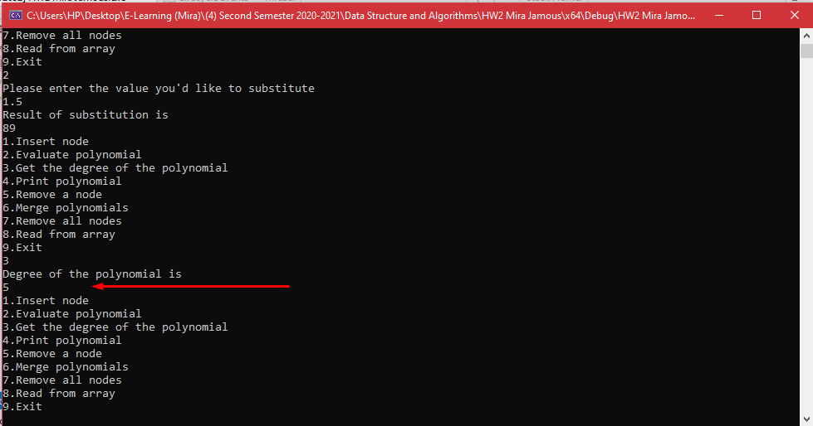4)the degree of the polynomial is 5 as it shows in the screenshot below

5)here’s a test of the overloading of operator <<

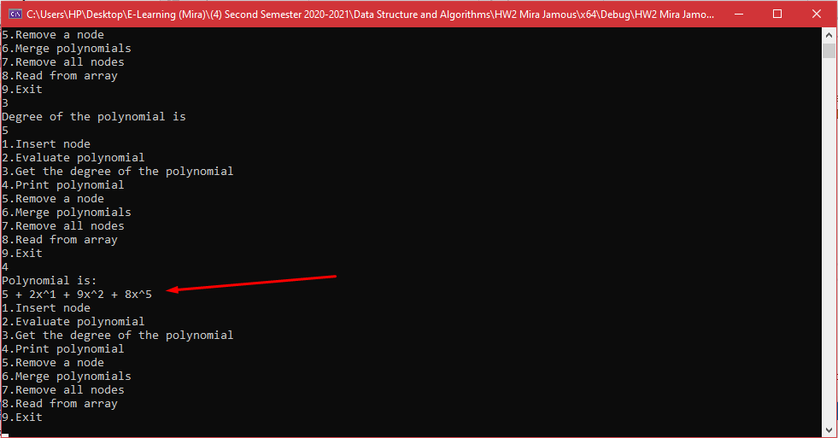By printing the poly to see the change after inserting a node

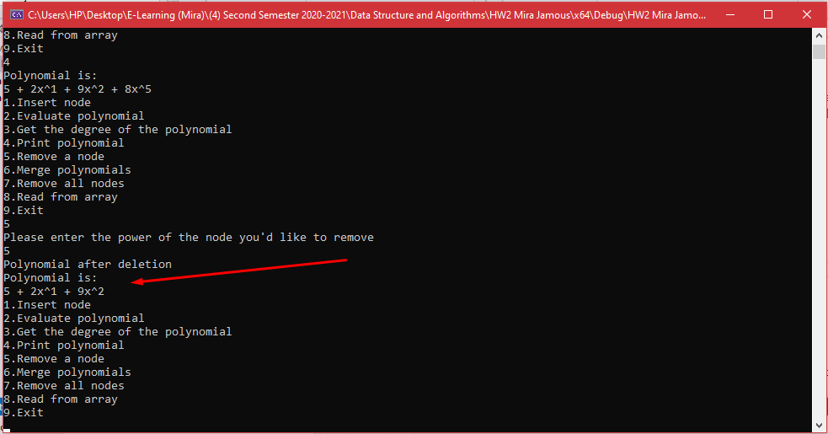6) removing the node with power 5 from the polynomial

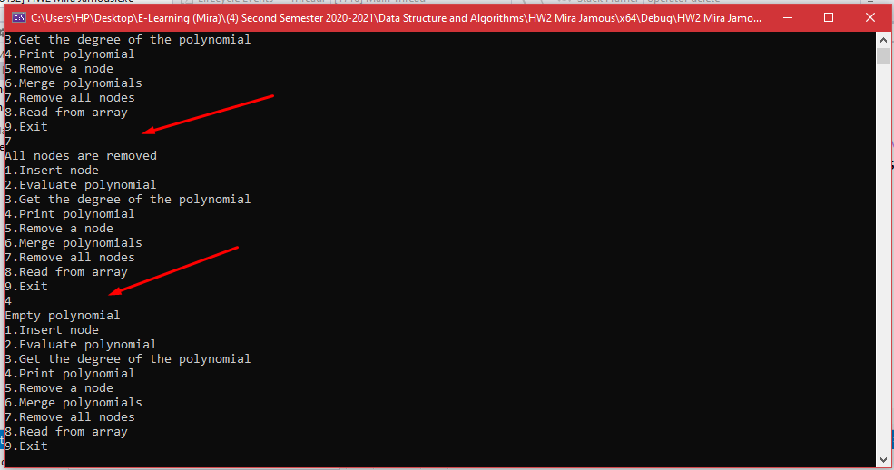7)here I started a new program once again and entered the same poly I entered at first to test the remove all nodes function, and it shows that the poly is empty after trying to print it

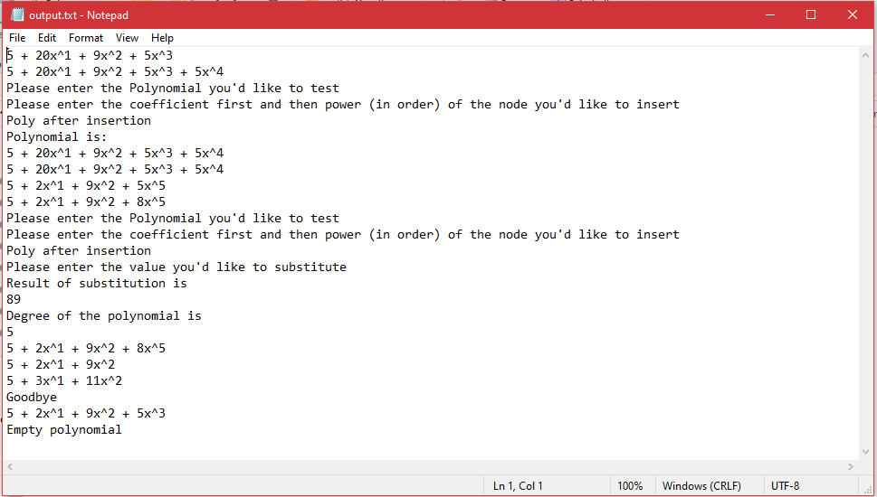8) Finally, here’s a proof that all operations in the program are printed out to an output file(which I deleted everything on when I handed in the assignment)